**1.Write a program to check if a number is positive, negative, or zero.**  
  
#include <stdio.h>

int main() {

int number;  
 scanf("%d", &number);

if (number > 0) {

printf("The number is positive.\n");

} else if (number < 0) {

printf("The number is negative.\n");

} else {

printf("The number is zero.\n");

}

return 0;

}

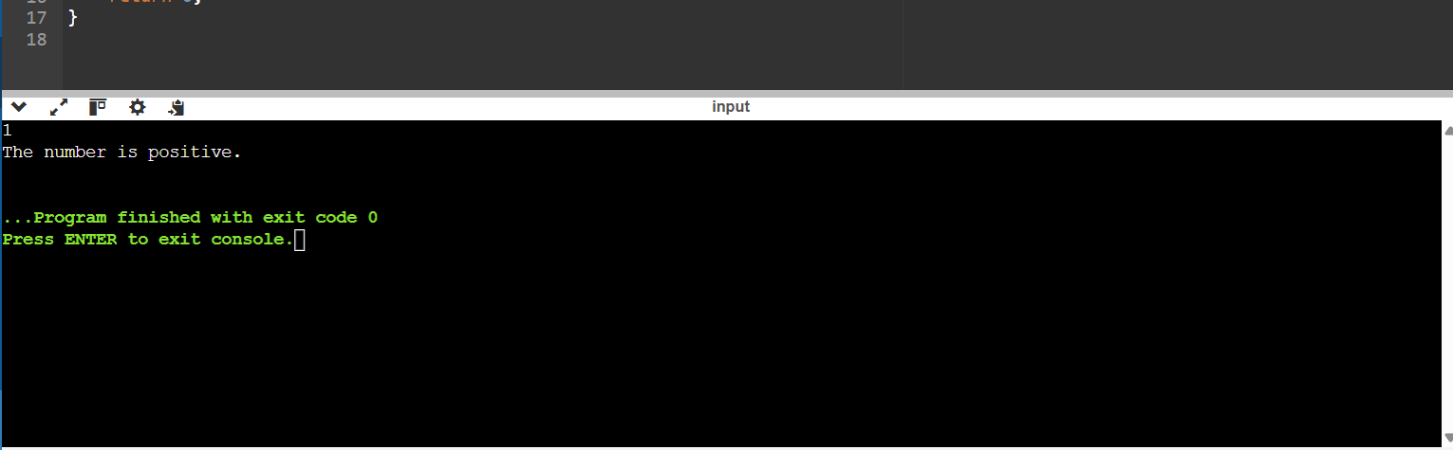

**2. Write a program to find the largest among three numbers.**  
  
#include <stdio.h>

int main() {

int num1, num2, num3;

scanf("%d %d %d", &num1, &num2, &num3);

if (num1 >= num2 && num1 >= num3) {

printf("The largest number is: %d\n", num1);

} else if (num2 >= num1 && num2 >= num3) {

printf("The largest number is: %d\n", num2);

} else {

printf("The largest number is: %d\n", num3);

}

return 0;

}

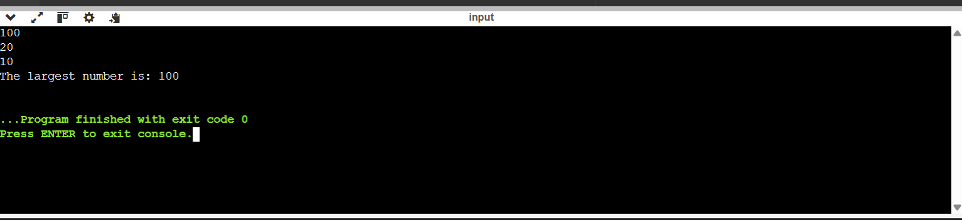

**3. Write a program to check if a year is a leap year.**  
  
#include <stdio.h>

int main() {

int year;

scanf("%d", &year);

if ((year % 4 == 0 && year % 100 != 0) || (year % 400 == 0)) {

printf("%d is a leap year.\n", year);

} else {

printf("%d is not a leap year.\n", year);

}

return 0;

}

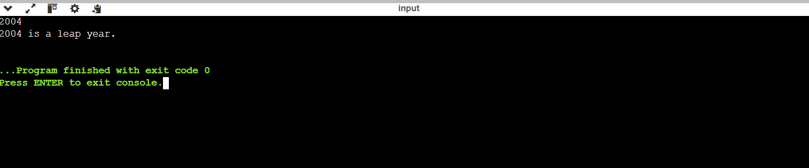

**4. Write a program to check whether a character is a vowel or consonant**  
  
#include <stdio.h>

int main() {

char ch;

scanf(" %c", &ch);

if (ch=='a'||ch=='e'||ch=='i'||ch=='o'||ch=='u'||ch=='A'||ch=='E'||ch=='I'||ch=='O'||ch=='U')

printf("Vowel\n");

else

printf("Consonant\n");

return 0;

}

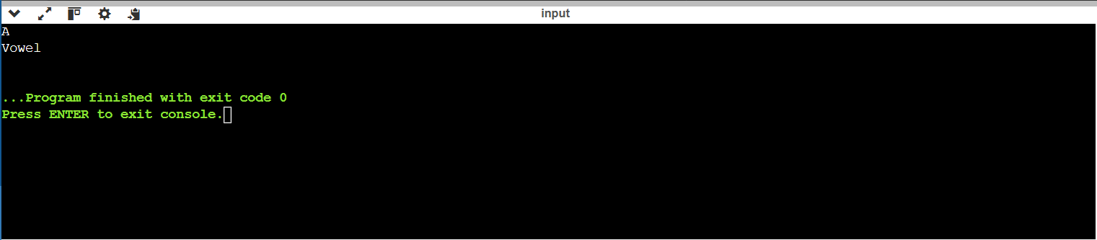

**5. Assign grades based on marks**

#include <stdio.h>

int main() {

int marks;

scanf("%d", &marks);

if (marks >= 90)

printf("Grade: A\n");

else if (marks >= 80)

printf("Grade: B\n");

else if (marks >= 70)

printf("Grade: C\n");

else if (marks >= 60)

printf("Grade: D\n");

else

printf("Grade: F\n");

return 0;

}

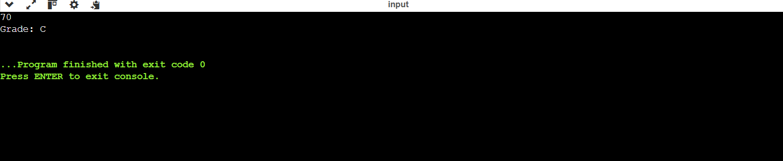

**6. Check whether a number is divisible by 5 and 11**

#include <stdio.h>

int main() {

int num;

scanf("%d", &num);

if (num % 5 == 0 && num % 11 == 0)

printf("Divisible by 5 and 11\n");

else

printf("Not divisible by 5 and 11\n");

return 0;

}

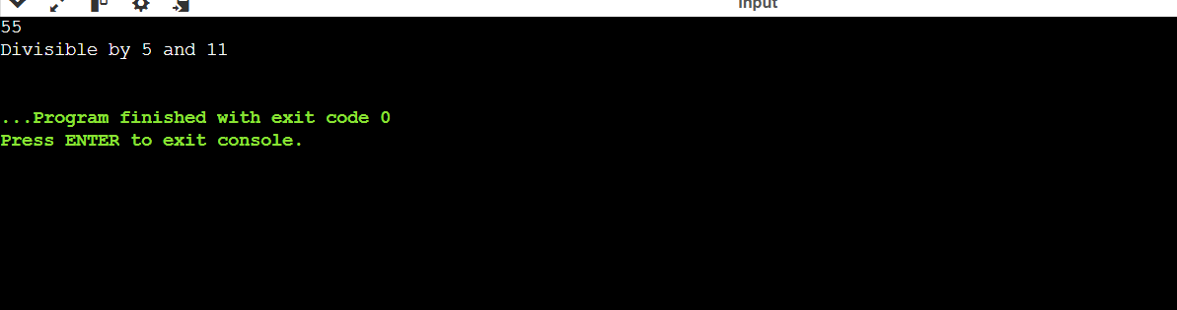

**7. Write a program to find the absolute value of a number.**

#include <stdio.h>

int main() {

int num;

scanf("%d", &num);

if (num < 0)

num = -num;

printf("Absolute value: %d\n", num);

return 0;

}

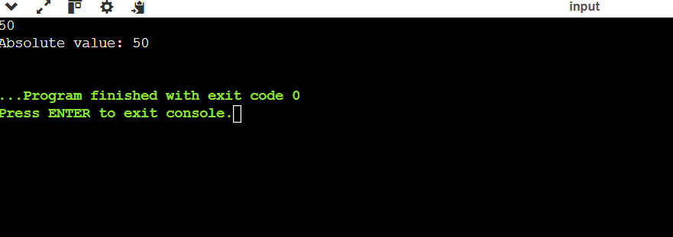

**8. Write a menu-driven program to perform +, -, *, / operations.**

#include <stdio.h>

int main() {

int choice;

float a, b, result;

printf("1. Add\n2. Subtract\n3. Multiply\n4. Divide\nEnter your choice: ");

scanf("%d", &choice);

printf("Enter two numbers: ");

scanf("%f %f", &a, &b);

switch (choice) {

case 1: result = a + b;

printf("Result: %.2f\n", result);

break;

case 2: result = a - b;

printf("Result: %.2f\n", result);

break;

case 3: result = a * b;

printf("Result: %.2f\n", result);

break;

case 4: if (b != 0)

result = a / b;

else {

printf("Cannot divide by zero\n");

return 1;

}

printf("Result: %.2f\n", result);

break;

default: printf("Invalid choice\n");

}

return 0;  
}

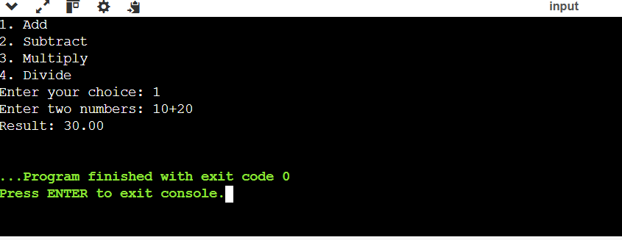

**9. Write a program to find roots of a quadratic equation.**#include <stdio.h>

#include <math.h>

int main() {

float a, b, c, d;

printf("Enter a b c: ");

scanf("%f%f%f", &a, &b, &c);

d = b*b - 4*a*c;

if (d > 0)

printf("Roots: %.2f and %.2f\n", (-b+sqrt(d))/(2*a), (-b-sqrt(d))/(2*a));

else if (d == 0)

printf("Root: %.2f\n", -b/(2*a));

else

printf("Complex roots\n");

return 0;

}  
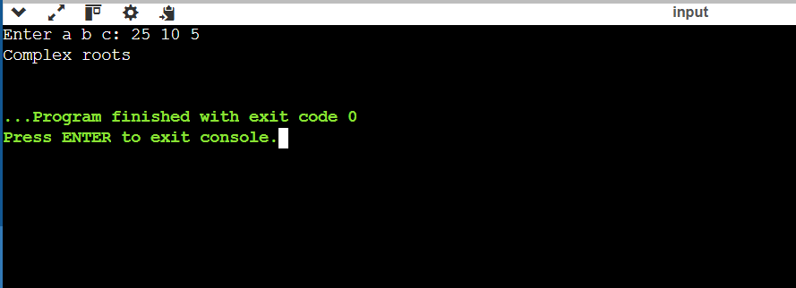

**10. Find the number of digits in a number**

#include <stdio.h>

int main() {

int num, count = 0;

printf("Enter a number: ");

scanf("%d", &num);

if (num == 0)

count = 1;

else {

while (num != 0) {

num /= 10;

count++;

}

}

printf("Number of digits: %d\n", count);

return 0;

}  
  
